PRESS RELEASE-SINCLAIR CLARK
15^{h} February 2021

FRESHWATER STRIKES OFF-MARKET LETTING DEAL: 16.010 SQ FT OFFICE IN SIMPSON HOUSE CROYDON

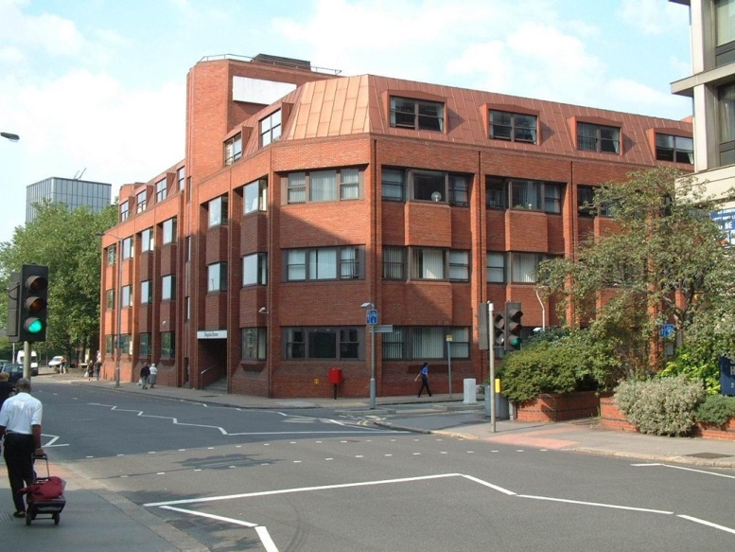

Freshwater has attracted the UK government in the form of Department for Work and Pensions (DWP), who have taken a 5-year lease on three floors at Simpson House.

The floors were previously occupied by Jacobs Babtie who have now taken an early surrender and relocated to the South Bank.

DWP will be using the space for as a training and skills facility.

The letting follows a spate of Freshwater activity across their Croydon portfolio including the re-negotiation of 5,000 sq ft of offices in Simpson House to Aston Lark, office lettings to Artech 2000 and Reed Partnership in Suffolk House and the renewal of leases to Tide Construction in both St Matthews House and 96 George Street.

The government sector is continuing to provide a robust source of demand for Croydon.

Sinclair Clark advised the Freshwater Group throughout and Cushman advised DWP.

12^{5h} February 2021

